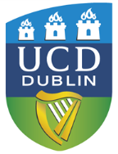UCD School of Public Health, Physiotherapy & Sports Science Taught Graduate Programmes
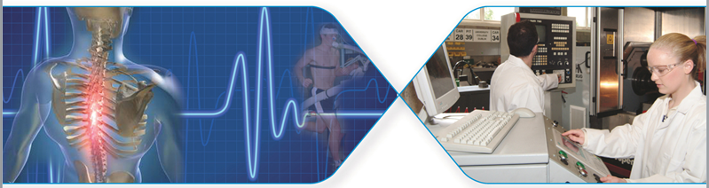

Professional Certificate in Spinal Studies
This is a part-time taught graduate programme educating health professionals on the vertebral column which is designed improve ability to work with patients with spinal pain and pathology.
Course description
This is a 15-credit taught graduate programme that offers an opportunity for Doctors and physiotherapists to improve their understanding, knowledge and ability to assess and manage pathologies of the vertebral column. It addresses the fundamentals of common pathologies and recent developments in treatment. Students will develop their knowledge base of functional anatomy and spinal pathology to allow them to recognise clinical patterns for diagnosis, treatment and delegation/referral.
Core subjects include: 1) function and anatomy; 2) degeneration and the Spine; 3) spinal deformity; 4) spinal trauma and 5) spinal tumours and infections, 6) sport and the spine; 7) occupational health and the spine and 9) medical conditions affecting the spine. Special topics of interest also include: Pain Mechanisms, Spinal Manipulations, Core Stability, Stratified Care, Imaging Modalities.
Facilities and Resources
This programme is run over 4 weekends (8 full days, Fridays and Saturdays in Sept, Oct, Nov and Dec) This programme is delivered part-time in the UCD Health Sciences building in lecture rooms and practical clinical teaching laboratories. In this programme you will have access to UCD IT, library and student facilities.
For further information see: https://sisweb.ucd.ie/usis/!W_HU_MENU.P_PUBLISH?p_tag=PROG&MAJR=X897
Course director: Dr Ulrik McCarthy Persson, Associate Professor-Physiotherapist and Mr Derek Cawley, Spinal Surgeon, email: ulrik.mccarthypersson@ucd.ie

